**UNIVERSITY APP**

**A MINI-PROJECT REPORT**

**18CSC207J - ADVANCED PROGRAMMING PRACTICE**

***Submitted by***

**GAURANG ASHAVA (RA2111027010007)**

**SYED ADNAN HUSSAINY (RA2111027010008)**

*Under the guidance of*

**Dr. Sasikumar**

Assistant Professor, Department of Computer Science and Engineering

***in partial fulfillment of the award of the degree***

***of***

**BACHELOR OF TECHNOLOGY**

in

**COMPUTER SCIENCE & ENGINEERING**

of

**FACULTY OF ENGINEERING AND TECHNOLOGY**



S.R.M. Nagar, Kattankulathur, Chengalpattu District

**MAY 2023**

**SRM INSTITUTE OF SCIENCE AND TECHNOLOGY**

(Under Section 3 of UGC Act, 1956)

**BONAFIDE CERTIFICATE**

Certified that the Mini project report titled **“COLLEGE HOSTEL MANAGEMENT SYSTEM”** is the bonafide work of **GAURANG ASHAVA (RA2111027010007) & SYED ADNAN HUSSAINY (RA2111027010008)** who carried out the minor project under my supervision. Certified further, that to the best of my knowledge, the work reported herein does not form any other project report or dissertation based on which a degree or award was conferred on an earlier occasion on this or any other candidate.

|  |  |
| --- | --- |
| **SIGNATURE** | **SIGNATURE** |
|  |  |
| Dr. Sasikumar | Dr. M Lakshmi |
| **SUPERVISOR** | **HEAD OF THE DEPARTMENT** |
| Assistant Professor | Professor and Head |
| Department of Data Science and Business Systems | Department of Data Science and Business Systems |

**ABSTRACT**

This project presents a University Hostel Management System implemented using Python, Tkinter, and a database. The system is designed to simplify the management of hostel accommodation for university students.

The system has two main user interfaces: one for administrators and another for students. The administrator interface allows for adding new hostels, allocating rooms to students, and managing student records. The student interface allows students to view their allocated rooms, make room transfer requests, and view hostel information.

The system is implemented using Python's Tkinter library for the graphical user interface, and a database is used to store all data related to the hostels and students. The database is designed to store and retrieve data while maintaining integrity. The system offers various features such as generating reports and managing billing.

Overall, the University Hostel Management System provides a simple, yet effective way of managing hostel accommodation for university students. It eliminates manual processes and enhances accuracy and efficiency.

It is an effective tool for hostel administrators and students, making the entire process streamlined and user-friendly.

**TABLE OF CONTENTS**

[**ABSTRACT**](https://docs.google.com/document/d/1h1DsqUmJ6_g7tYs9SrdPH9y3odiSzyYWtwN41SEo-2g/edit#heading=h.tyjcwt)  3

**TABLE OF CONTENTS** 4

[**ABBREVIATIONS**](https://docs.google.com/document/d/1h1DsqUmJ6_g7tYs9SrdPH9y3odiSzyYWtwN41SEo-2g/edit#heading=h.2s8eyo1)  5

[**1 INTRODUCTION**](https://docs.google.com/document/d/1h1DsqUmJ6_g7tYs9SrdPH9y3odiSzyYWtwN41SEo-2g/edit#heading=h.3rdcrjn)  6

[**2 LITERATURE SURVEY**](https://docs.google.com/document/d/1h1DsqUmJ6_g7tYs9SrdPH9y3odiSzyYWtwN41SEo-2g/edit#heading=h.1y810tw)  7

**3** [**SYSTEM A**](https://docs.google.com/document/d/1h1DsqUmJ6_g7tYs9SrdPH9y3odiSzyYWtwN41SEo-2g/edit#heading=h.4i7ojhp)**RCHITECTURE AND DESIGN** 8-9

3.1 Architecture diagram of the proposed Project             8

3.2 Description of Module and Components                                                                 9

**4    METHODOLOGY** 10

4.1 Methodological Steps             10

**5    CODING** 11

**6    SCREENSHOTS AND RESULTS**

6.1 Login Page 30

6.2 Home Page 30

6.3 Student Registration Page 31

6.4 Add New Room Page 31

6.5 In–Out Time Page                                                                                                      32

6.6 Visitor’s Page 32

6.7 View Information Page 33

6.8 Leave Application Page 33

**7    CONCLUSION AND FUTURE ENHANCEMENT** 34

7.1 Conclusion 34

7.2 Future Enhancement 35

**8 REFERENCES** 36

**ABBREVIATIONS**

* **CHMS:-** College Hostel Management System
* **DOB :-** Date of Birth
* **BRD:-** Bedroom with Bed No.
* **DTH:-** Direct to Home Television
* **HOD :-** Hostel Office Desk
* **MT :-** Maintenance
* **GUI :-** Graphical User Interface
* **IDE :-** Integrated Development Environment
* **CRUD:-** Create, Read, Upload, Delete
* **DBMS :-** Database Management System
* **SQL :-** Structured Query Language
* **API :-** Application Programming Interface

**INTRODUCTION**

The University Hostel Management System is an application designed to provide efficient and reliable management of university hostel accommodation for both administrators and students.

The system is implemented using Python, Tkinter, and a database, which provide a user-friendly interface, powerful functionality, and efficient data management capabilities.

The system is designed to automate the entire process of managing hostel accommodation for university students. It simplifies the process of room allocation, billing, and management of student records.

The system provides two user interfaces: one for administrators and another for students. The administrator interface enables hostel administrators to manage hostel facilities, allocate rooms to students, and manage student records.

The student interface, on the other hand, enables students to view their allocated rooms, make room transfer requests, and access information about the hostels.

Python is a widely used programming language known for its simplicity, flexibility, and ease of use. The Tkinter library, which is a standard GUI toolkit for Python, provides an intuitive graphical interface for the system. The database used in the system is designed to store and retrieve data efficiently while maintaining data integrity.

The University Hostel Management System aims to eliminate manual processes and enhance accuracy and efficiency in managing hostel accommodation for university students. The system is an effective tool for hostel administrators and students, providing a streamlined and user-friendly process.

The system's features, including generating reports and managing bills, make it an essential tool for efficient and reliable management of hostel accommodation in universities.

**LITERATURE SURVEY**

The management of university hostels is an essential aspect of university administration, and over the years, various systems have been developed to simplify and streamline the process. In recent times, technological advancements have led to the development of computer-based systems for the management of hostel accommodation. In this literature survey, we review some related works that have been developed for the management of hostel accommodation in universities.

One study by Rajesh et al. (2018) presents a web-based system for the management of hostel accommodation in a university. The system is designed to automate the entire process of managing hostel accommodation for university students, including room allocation, billing, and managing student records. The system uses PHP and MySQL for the back end and HTML, CSS, and JavaScript for the front end. The system provides a user-friendly interface, and it has been tested and proven to be effective in managing hostel accommodation.

Another study by Ali et al. (2019) presents a hostel management system that uses a desktop-based application to manage hostel accommodation in a university. The system is designed to automate the process of managing student records, room allocation, and billing. The system is implemented using Java and MySQL, and it provides a user-friendly interface for hostel administrators and students.

In a different approach, Adeniyi et al. (2020) present a mobile-based system for the management of hostel accommodation in a university. The system uses a mobile application to provide students with access to hostel information, including room allocation, hostel facilities, and payment information. The system is implemented using Android and MySQL, and it provides a simple and efficient way for students to manage their hostel accommodation.

In this work, we present a University Hostel Management System implemented using Python, Tkinter, and a database. The system is designed to automate the entire process of managing hostel accommodation for university students, and it provides a user-friendly interface for hostel administrators and students. The system is expected to be effective in managing hostel accommodation, eliminating manual processes, and enhancing accuracy and efficiency.

**SYSTEM ARCHITECTURE**

The University Hostel Management System is implemented using a client-server architecture with a desktop-based client application and a database server. The system is designed to automate the process of managing hostel accommodation for university students, including room allocation, billing, and management of student records. The system is implemented using Python, Tkinter, and a database.

The client application is implemented using Python and Tkinter, which provide a user-friendly graphical interface for hostel administrators and students. The client application communicates with the database server using Structured Query Language (SQL) to retrieve and store data. The database server is implemented using a Relational Database Management System (RDBMS), which stores and manages data efficiently while ensuring data integrity.

The system is designed using a Model-View-Controller (MVC) architecture, which separates the system into three components: the model, view, and controller. The model represents the data and business logic of the system, the view represents the user interface, and the controller represents the application logic that mediates between the model and view.

The model component of the system consists of the database schema and the Python classes that represent the data entities in the database. The database schema defines the structure of the database and the relationships between data entities, while the Python classes provide an object-oriented interface for accessing and manipulating data.

**DESIGN**

The view component of the system consists of the user interface implemented using Tkinter. The user interface provides a graphical interface for hostel administrators and students to interact with the system. The user interface includes forms for inputting data, tables for displaying data, and buttons for triggering system events.

The controller component of the system consists of Python scripts that mediate between the model and view components. The controller scripts receive user input from the view, process the input, and update the model and view accordingly. The controller scripts also communicate with the database server to retrieve and store data.

Overall, the University Hostel Management System is designed to be a reliable and efficient system for managing hostel accommodation in universities. The system architecture and design provide a scalable and extensible framework that can be customized to meet the specific needs of different universities.

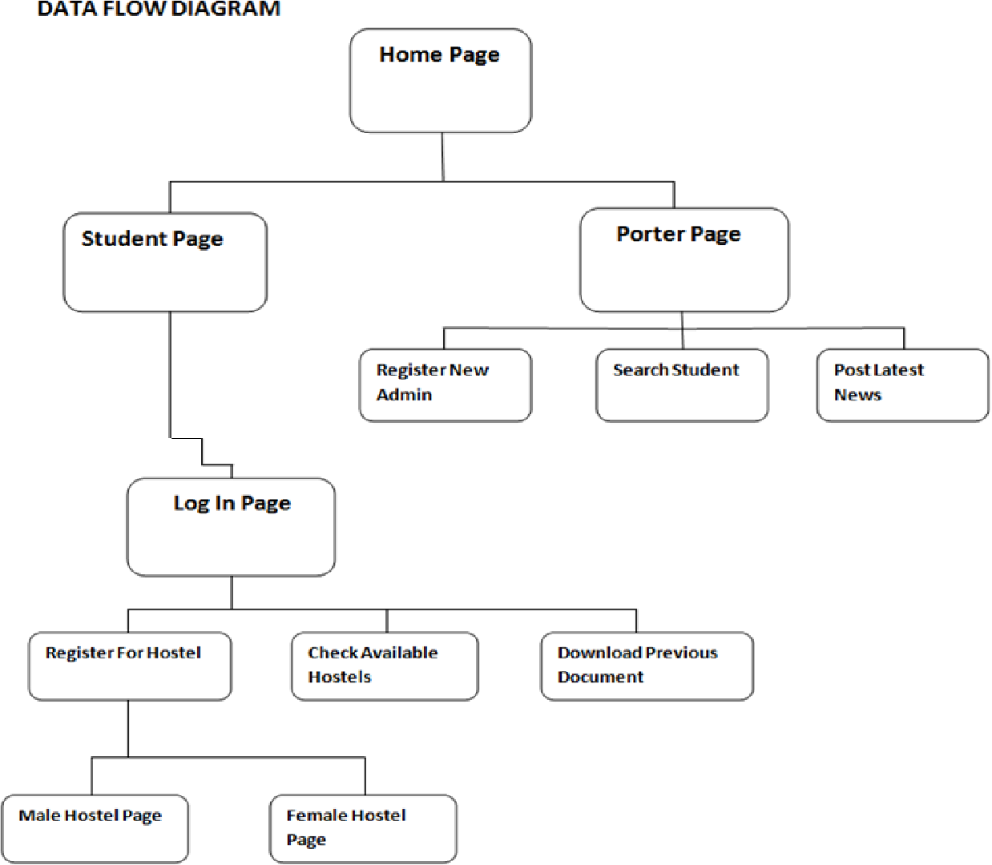

**METHODOLOGY**

The development of the University Hostel Management System using Python, Tkinter, and a database follows a structured methodology that includes the following steps:

1. **Requirements gathering:** The first step in the development process is to gather and analyze the requirements for the system. This involves identifying the needs of hostel administrators and students and the features and functionalities required in the system. The requirements are documented in a software requirements specification (SRS) document.
2. **System analysis and design:** In this step, the system is analysed and designed based on the requirements gathered in the previous step. The system is broken down into components, and the architecture and design of each component are determined. This involves creating a detailed design specification (DDS) document, which includes system requirements, use cases, data flow diagrams, class diagrams, and other system design details.
3. **Implementation:** The implementation phase involves the actual development of the system components. This step includes writing code for the client application using Python and Tkinter and setting up the database server using an RDBMS. The code is tested at various stages of development to ensure that it is functioning as expected.
4. **Integration and testing:** In this step, the different system components are integrated and tested to ensure that they work together seamlessly. This involves testing the system for bugs, errors, and other issues and fixing any issues that are found.
5. **Deployment and maintenance:** The final step in the development process is to deploy the system and maintain it. The system is deployed in the university hostel environment, and users are trained to use the system. The system is monitored for performance and security issues, and maintenance and support are provided as required.

Overall, the development of the University Hostel Management System follows a structured methodology that ensures that the system is developed in a systematic and organized manner. This methodology ensures that the system meets the requirements of hostel administrators and students and is reliable, efficient, and user-friendly.

**CODING**

from tkinter.ttk import *

from Tkinter import *

from PIL import ImageTk, Image

def date():

    from datetime import datetime

    # current date time

    now = datetime.now()

    t = now.strftime("%H:%M")

    s1 = now.strftime("%H:%M,%Y-%m-%d")

    s1 = str(s1)

    return s1 #returns Current Date And Time In String

base = Tk()

base.title("COLLEGE HOSTEL MANAGEMENT SYSTEM")

base.geometry(f'{1535}x{790}+{0}+{0}')

heading = Label(base, text="COLLEGE HOSTEL MANAGEMENT SYSTEM", font=("Arial 30 bold"), bg="lightseagreen", fg="white", padx=490, pady=20)

heading.pack()

canvas = Canvas(base, bg='silver', height=575, width=800)

canvas.place(x=330, y=130)

G = 1

def main():

    global G

    canvas = Canvas(base, bg='lightseagreen', height=675, width=310)

    canvas.place(x=-1, y=100)

    can = Canvas(base, bg='silver', height=675, width=1500)

    can.place(x=320, y=105)

    def add_stud():

        canvas = Canvas(base, bg='silver', height=675, width=1210)

        canvas.place(x=320, y=105)

        first_name = Label(base, text="First Name", font=("Arial 15 bold"), bg='silver', fg="black")

        first_name.place(x=400, y=150)

        fir_name_entry = Entry(base, width=15, font=("Arial 15"))

        fir_name_entry.place(x=400, y=180)

        fir_name_entry.focus()

        last_name = Label(base, text="Last Name", font=("Arial 15 bold"), bg="silver", fg="black")

        last_name.place(x=610, y=150)

        last_name_entry = Entry(base, width=15, font=("Arial 15"))

        last_name_entry.place(x=610, y=180)

        father_name = Label(base, text="Father Name", font=("Arial 15 bold"), bg="silver", fg="black")

        father_name.place(x=400, y=220)

        fathr_name_entry = Entry(base, width=15, font=("Arial 15"))

        fathr_name_entry.place(x=400, y=250)

        mother_name = Label(base, text="Mother Name", font=("Arial 15 bold"), bg="silver", fg="black")

        mother_name.place(x=610, y=220)

        mther_name_entry = Entry(base, width=15, font=("Arial 15"))

        mther_name_entry.place(x=610, y=250)

        dob = Label(base, text="DOB", font=("Arial 15 bold"), bg="silver", fg="black")

        dob.place(x=400, y=300)

        dob_entry = Entry(base, width=15, font=("Arial 15 bold"))

        dob_entry.place(x=400, y=330)

        m1 = Label(base, text="(Y-M-D)", font=("Arial 12 bold"), bg="silver", fg="black")

        m1.place(x=450, y=300)

        contact = Label(base, text="Roll No", font=("Arial 15 bold"), bg="silver", fg="black")

        contact.place(x=610, y=300)

        cont_entry = Entry(base, width=15, font=("Arial 15 bold"))

        cont_entry.place(x=610, y=330)

        message = Label(base, text="(Roll No. will be your Hostel ID)", font=("Arial 10 bold"), bg="silver",fg="black")

        message.place(x=690, y=300)

        email = Label(base, text="Email", font=("Arial 15 bold"), bg="silver", fg="black")

        email.place(x=400, y=370)

        email_entry = Entry(base, width=15, font=("Arial 15 bold"))

        email_entry.place(x=400, y=410)

        address = Label(base, text="Address", font=("Arial 15 bold"), bg="silver", fg="black")

        address.place(x=610, y=370)

        addrs_entry = Entry(base, width=15, font=("Arial 15 bold"))

        addrs_entry.place(x=610, y=410)

        vehicle = Label(base, text="Vehicle No.", font=("Arial 15 bold"), bg="silver", fg="black")

        vehicle.place(x=400, y=450)

        vehicle_entry = Entry(base, width="15", font=("Arial 15 bold"))

        vehicle_entry.place(x=400, y=490)

        m2 = Label(base, text="(MH20EU9295)", font=("Arial 11 bold"), bg="silver", fg="black")

        m2.place(x=470, y=450)

        work_place = Label(base, text="Work Place/College", font=("Arial 15 bold"), bg="silver", fg="black")

        work_place.place(x=610, y=450)

        place_entry = Entry(base, width="15", font=("Arial 15 bold"))

        place_entry.place(x=610, y=490)

        gender = Label(base, text="Gender", font=("Arial 15 bold"), bg="silver", fg="black")

        gender.place(x=400, y=580)

        G = 1

        def selected():

            global G

            if c1.get() == 1:

                G = 1

            elif c1.get() == 2:

                G = 2

            elif c1.get() == 0:

                G = 0

            else:

                G = 1

        c1 = IntVar()

        a = Radiobutton(base, text="Male", bg="silver", fg="black", font=("Arial 15 bold"), variable=c1, value=1, command=selected)

        b = Radiobutton(base, text="Female", bg="silver", fg="black", font=("Arial 15 bold"), variable=c1, value=2, command=selected)

        c = Radiobutton(base, text="Other", bg="silver", fg="black", font=("Arial 15 bold"), variable=c1, value=0, command=selected)

        a.place(x=490, y=580)

        b.place(x=580, y=580)

        c.place(x=680, y=580)

        def available_roome():

            rooms_availble = Label(base, text="Rooms Available", font=("Arial 20 bold"), bg="lightseagreen", fg="white", padx=140)

            rooms_availble.place(x=1005, y=110)

            x = " Room No. | Beds"

            room = Label(base, text=x, font=("Arial 15 bold"), bg="dark slate grey", fg="white")

            room.place(x=1005, y=150)

            global G

            bed1 = None

            bed2 = None

            bed3 = None

            if G == 1:

                f1 = open("room_info_boys.txt","r")

                bed1 = "B1"

                bed2 = "B2"

                bed3 = "B3"

            elif G==2:

                f1 = open("room_info_girls.txt","r")

                bed1 = "G1"

                bed2 = "G2"

                bed3 = "G3"

            elif G==0:

                f1 = open("room_info_others.txt","r")

                bed1 = "O1"

                bed2 = "O2"

                bed3 = "O3"

            else:

                file_name = "room_info_boys.txt"

                bed1 = "B1"

                bed2 = "B2"

                bed3 = "B3"

            all_lines = f1.readlines()

            count = 1

            rooms = []

            for i in all_lines:

                temp1 = str(i)

                one_line = temp1.split(',')

                if one_line[1] == bed1 and one_line[2] == bed2 and one_line[3] == bed3:

                    temp = []

                    count = 2

                    temp.append(one_line[0])

                    temp.append(bed1)

                    temp.append(bed2)

                    temp.append(bed3)

                    rooms.append(temp)

                if one_line[1] != bed1 and one_line[2] == bed2 and one_line[3] == bed3:

                    count = 2

                    temp = []

                    temp.append(one_line[0])

                    temp.append("NA")

                    temp.append(bed2)

                    temp.append(bed3)

                    rooms.append(temp)

                if one_line[1] == bed1 and one_line[2] != bed2 and one_line[3] == bed3:

                    temp = []

                    count = 2

                    temp.append(one_line[0])

                    temp.append(bed1)

                    temp.append("NA")

                    temp.append(bed3)

                    rooms.append(temp)

                if one_line[1] == bed1 and one_line[2] == bed2 and one_line[3] != bed3:

                    temp = []

                    count = 2

                    temp.append(one_line[0])

                    temp.append(bed1)

                    temp.append(bed2)

                    temp.append("NA")

                    rooms.append(temp)

                if one_line[1] == bed1 and one_line[2] != bed2 and one_line[3] != bed3:

                    temp = []

                    count = 2

                    temp.append(one_line[0])

                    temp.append(bed1)

                    temp.append("NA")

                    temp.append("NA")

                    rooms.append(temp)

                if one_line[1] != bed1 and one_line[2] == bed2 and one_line[3] != bed3:

                    temp = []

                    count = 2

                    temp.append(one_line[0])

                    temp.append("NA")

                    temp.append(bed2)

                    temp.append("NA")

                    rooms.append(temp)

                if one_line[1] != bed1 and one_line[2] != bed2 and one_line[3] == bed3:

                    temp = []

                    count = 2

                    temp.append(one_line[0])

                    temp.append("NA")

                    temp.append("NA")

                    temp.append(bed3)

                    rooms.append(temp)

                if one_line[1] != bed1 and one_line[2] != bed2 and one_line[3] != bed3:

                    temp = []

                    count = 2

                    temp.append("--")

                    temp.append("NA")

                    temp.append("NA")

                    temp.append("NA")

                    rooms.append(temp)

            if count == 1:

                y = "No Rooms Available"

                x = Label(base, text=y, font=("Arial", 40), bg="dark slate grey", fg="white")

                x.place(x=1020, y=300)

            else:

                x1co = 1150

                y1co = 200

                x2co = 1350

                y2co = 200

                flag = 1

                for i in rooms:

                    r_no = Label(base, text=i[0], font=("Arial", 15), bg="silver", fg="black")

                    r_no.place(x=x1co, y=y1co)

                    y = i[1] + " " + i[2] + " " + i[3]

                    r_bk_no = Label(base, text=y, font=("Arial", 15), bg="silver", fg="black")

                    r_bk_no.place(x=x2co, y=y2co)

                    y1co = y1co + 40

                    y2co = y2co + 40

                    count = 2

                    if flag >= 8:

                        break

                    flag = flag + 1

            f1.close()

            c1 = Canvas(base, height=2, width=600)

            c1.place(x=1000, y=550)

            r1 = Label(base, text="Room No.", font=("Arial 15 bold"), bg="silver", fg="black")

            r1.place(x=1040, y=570)

            r2 = Entry(base, width=15, font=("Arial 15 bold"))

            r2.place(x=1150, y=570)

            r3 = Label(base, text="Bed No.", font=("Arial 15 bold"), bg="silver", fg="black")

            r3.place(x=1040, y=610)

            r4 = Entry(base, width=15, font=("Arial 15 bold"))

            r4.place(x=1150, y=610)

            r5 = Label(base, text="(B1 B2 B3)", font=("Arial 10 bold"), bg="silver", fg="black")

            r5.place(x=1040, y=640)

            r6 = Label(base, text="( Girl = G1 )", font=("Arial 15 bold"), bg="silver", fg="black")

            r6.place(x=1350,y=570)

            r7 = Label(base, text="( Other = O1)",font=("Arial 15 bold"), bg="silver", fg="black")

            r7.place(x=1350,y=610)

            def student():

                global G

                bed1 = None

                bed2 = None

                bed3 = None

                file_name = None

                if G == 1:

                    file_name = "room_info_boys.txt"

                    bed1 = "B1"

                    bed2 = "B2"

                    bed3 = "B3"

                elif G == 2:

                    file_name = "room_info_girls.txt"

                    bed1 = "G1"

                    bed2 = "G2"

                    bed3 = "G3"

                elif G == 0:

                    file_name = "room_info_others.txt"

                    bed1 = "O1"

                    bed2 = "O2"

                    bed3 = "O3"

                else:

                    file_name = "room_info_boys.txt"

                    bed1 = "B1"

                    bed2 = "B2"

                    bed3 = "B3"

                f1 = open("student_info.txt", "a")

                f2 = open(file_name,"a")

                n = str(fir_name_entry.get()) + " "

                b = str(r4.get()).upper()

                ln = str(last_name_entry.get()).lower()

                f = str(fathr_name_entry.get()).lower()

                m = str(mther_name_entry.get()).lower()

                d = str(dob_entry.get()).lower()

                add = str(addrs_entry.get()).lower()

                c = str(cont_entry.get()).lower()

                e = str(email_entry.get())

                w = str(place_entry.get()).lower()

                v = str(vehicle_entry.get()).lower()

                da = date().lower()

                rom = str(r2.get()).lower()

                f1.write(

                c + "," + n + ln + "," + f + "," + m + "," + d + "," + e + "," + w + "," + v + "," + da + "," +

                b + "," + rom + "," + "\n")

                f1.close()

                fobj = open(file_name, "r")

                fdata_ls = fobj.readlines()

                fobj.close()

                rdate = date()

                fobj = open(file_name, "w")

                if b == bed1:

                    for oneline in fdata_ls:

                        if oneline.startswith(rom + ",") and oneline.__contains__(","+bed1):  # write date

                            new_oneline = oneline.replace(","+bed1+",", "," + c + ",")

                            new_oneline2 = new_oneline.replace(",NOT,", "," + rdate + ",")

                            fobj.write(new_oneline)

                        else:

                            fobj.write(oneline)

                else:

                    if b == bed2:

                        for oneline in fdata_ls:

                            if oneline.startswith(rom + ",") and oneline.__contains__(","+bed2): # write date

                                new_oneline = oneline.replace(","+bed2+"," , "," + c + ",")

                                new_oneline2 = new_oneline.replace(",NOT," , "," + rdate + ",")

                                fobj.write(new_oneline)

                            else:

                                fobj.write(oneline)

                    else:

                        for oneline in fdata_ls:

                            if oneline.startswith(rom + ",") and oneline.__contains__(","+bed3): # write date

                                new_oneline = oneline.replace(","+bed3+"," , "," + c + ",")

                                new_oneline2 = new_oneline.replace(",NOT," , "," + rdate + ",")

                                fobj.write(new_oneline)

                            else:

                                fobj.write(oneline)

                fobj.close()

                l = Label(base, text="Student Added Successfully....!", font=("Arial 15 bold"), bg='silver', fg="black")

                l.place(x=1150, y=650)

            add_student = Button(base, text="Save", font=("Arial 20 bold"), bg="white", fg="black" ,command=student)

            add_student.place(x=1050, y=700)

        c1 = IntVar()

        a = Radiobutton(base, text="Male", bg="silver", fg="black", font=("Arial 15 bold"), variable=c1, value=1, command=selected)

        b = Radiobutton(base, text="Female", bg="silver", fg="black", font=("Arial 15 bold"), variable=c1, value=2, command=selected)

        c = Radiobutton(base, text="Other", bg="silver", fg="black", font=("Arial 15 bold"), variable=c1, value=0, command=selected)

        a.place(x=490,y=580)

        b.place(x=580,y=580)

        c.place(x=680,y=580)

        continu = Button(base, text="Continue", font=("Arial 15 bold"), bg="white", fg="black", command=available_roome)

        continu.place(x=490, y=670)

        line = Canvas(base, height=670, width=2)

        line.place(x=1000, y=105)

    def add_room():

            canvas = Canvas(base, bg='silver', height=675, width=1210)

            canvas.place(x=320, y=105)

            h1 = Label(base, text="Add New Room", bg="dark slate grey", font=("Arial 20 bold"), fg="white", padx=500, pady=10)

            h1.place(x=320, y=105)

            n_rm_n = Label(base, text="New Room No.", font=("Arial 20 bold"), bg="silver", fg="black")

            n_rm_n.place(x=500, y=300)

            rm_n_entry = Entry(base, width=20, font=("Arial 15 bold"))

            rm_n_entry.place(x=750, y=303)

            gender = Label(base,text="Gender", font=("Arial 20 bold"), bg="silver", fg="black")

            gender.place(x=500,y=350)

            global G

            G = 1

            def selected():

                global G

                if c1.get() == 1:

                    G = 1

                if c1.get() == 2:

                    G = 2

                if c1.get() == 0:

                    G = 0

            c1 = IntVar()

            a = Radiobutton(base, text="Male", bg="silver", fg="black", font=("Arial 15 bold"), variable=c1, value=1, command=selected)

            b = Radiobutton(base, text="Female", bg="silver", fg="black", font=("Arial 15 bold"), variable=c1, value=2, command=selected)

            c = Radiobutton(base, text="Other", bg="silver", fg="black", font=("Arial 15 bold"), variable=c1, value=0, command=selected)

            a.place(x=750, y=350)

            b.place(x=840, y=350)

            c.place(x=950, y=350)

            def add():

                file_name = ""

                bed1 = bed2 = bed3 = None

                r = (rm_n_entry.get())

                if G==1:

                    bed1 = "B1"

                    bed2 = "B2"

                    bed3 = "B3"

                    file_name = "room_info_boys.txt"

                    f2 = open(file_name, "r")

                if G==2:

                    bed1 = "G1"

                    bed2 = "G2"

                    bed3 = "G3"

                    file_name = "room_info_girls.txt"

                    f2 = open(file_name, "r")

                if G==0:

                    bed1 = "O1"

                    bed2 = "O2"

                    bed3 = "O3"

                    file_name = "room_info_others.txt"

                    f2 = open(file_name, "r")

                all_lines = f2.readlines()

                count = 0

                for i in all_lines:

                    temp = str(i)

                    one_line = temp.split(',')

                    if one_line[0] == r:

                        l = Label(base, text="Room Is Already Addded....!", font=("Arial 25 bold"), bg='silver', fg="black")

                        l.place(x=650, y=600)

                        f2.close()

                        count = 2

                f2.close()

                if count != 2:

                    q = "NOT"

                    f1 = open(file_name, "a")

                    f1.write(r + "," + bed1 + "," + bed2 + "," + bed3 + "," + q + "," + "\n")

                    f1.close()

                    l = Label(base, text="ROOM Successfully Added....!", font=("Arial 25 bold"), bg='silver', fg="black")

                    l.place(x=650, y=600)

            ad_rm_btn = Button(base, text="Add Room", font=("Arial 20 bold"), bg="white", fg="black", command=add)

            ad_rm_btn.place(x=550, y=500)

    def in_out_time():

            canvas = Canvas(base, bg='silver', height=675, width=1210)

            canvas.place(x=320, y=105)

            a = "---------------Outtime---------------"

            out_time_h1 = Label(base, text=a, font=("Arial 20 bold"), bg="dark slate grey", fg="white", padx=20, pady=10)

            out_time_h1.place(x=320, y=115)

            out_time = Label(base, text="Enter ID", font=("Arial 20 bold"), bg="silver", fg="black")

            out_time.place(x=470, y=200)

            out_time_entry = Entry(base, width=20, font=("Arial 20 bold"))

            out_time_entry.place(x=620, y=200)

            out_time_entry.focus()

            purpose = Label(base, text="Purpose", font=("Arial 20 bold"), bg="silver", fg="black")

            purpose.place(x=470, y=270)

            purpose_entry = Entry(base, width=20, font=("Arial 20 bold"))

            purpose_entry.place(x=620, y=270)

            def save1():

                Id = str(out_time_entry.get())

                pur1 = str(purpose_entry.get())

                t = date()

                f1 = open("inouttime.txt", "a")

                f1.write(Id + "," + pur1 + "," + t + "," + "OUTTIME" + "," + "REMARK" + "\n")

                f1.close()

                done = Label(base, text="Successfull...!", font=("Arial 20 bold"), bg="silver", fg="black")

                done.place(x=1200, y=220)

            save1 = Button(base, text="Save", font=("Arial 20 bold"), bg="white", fg="black", command=save1)

            save1.place(x=1050, y=220)

            a1 = "---------------Inttime---------------"

            in_time_h1 = Label(base, text=a1, font=("Arial 20 bold"), bg="dark slate grey", fg="white", padx=20, pady=10)

            in_time_h1.place(x=320, y=400)

            in_time = Label(base, text="Enter ID", font=("Arial 20 bold"), bg="silver", fg="black")

            in_time.place(x=470, y=500)

            in_time_entry = Entry(base, width=20, font=("Arial 20 bold"))

            in_time_entry.place(x=680, y=500)

            in_time_entry.focus()

            ot_entry = Label(base, text="Outtime Entry", font=("Arial 20 bold"), bg="silver", fg="black")

            ot_entry.place(x=470, y=550)

            ot_entry_entry = Entry(base, width=20, font=("Arial 20 bold"))

            ot_entry_entry.place(x=680, y=550)

            def search_outtime():

                s_id = str(in_time_entry.get())

                fobj = open("inouttime.txt", "r")

                fdata_ls = fobj.readlines()

                count = 1

                for oneline in fdata_ls:

                    if oneline.startswith(s_id + ",") and oneline.__contains__(",OUTTIME,"): # write date

                        count = 2

                        y = oneline.split(",")

                        tv = StringVar()

                        tv.set(y[2] + " " + y[3])

                        ot = Entry(base, width=20, textvariable=tv, font=("Arial 20 bold"))

                        ot.place(x=680, y=550)

                        break

                fobj.close()

                if count == 1:

                    tv = StringVar()

                    tv.set("Invalid Id")

                    ot = Entry(base, width=20, textvariable=tv, font=("Arial 20 bold"))

                    ot.place(x=680, y=550)

            def save2():

                sel_opt = str(r_sel.get())

                s_id = str(in_time_entry.get())

                fobj = open("inouttime.txt", "r")

                fdata_ls = fobj.readlines()

                fobj.close()

                rdate = date()

                count = 1

                fobj = open("inouttime.txt", "w")

                for oneline in fdata_ls:

                    if oneline.startswith(s_id + ",") and oneline.__contains__(",OUTTIME,"):  # write date

                        new_oneline = oneline.replace(",OUTTIME,", "," + rdate + ",")

                        new_oneline2 = new_oneline.replace(",REMARK", "," + sel_opt + ",")

                        fobj.write(new_oneline2)

                        count = 2

                    else:

                        fobj.write(oneline)

                if count == 2:

                    done = Label(base, text="Successful...!", font=("Arial 20 bold"), bg="silver", fg="black")

                    done.place(x=700, y=720)

                if count == 1:

                    done = Label(base, text="Please Give Correct Information", font=("Arial 20 bold"), bg="silver", fg="black")

                    done.place(x=600, y=720)

                fobj.close()

            sear_ot = Button(base, text="Search Outtime", font=("Arial 18 bold"), bg="white", command=search_outtime)

            sear_ot.place(x=1050, y=520)

            save2 = Button(base, text="Save", font=("Arial 20 bold"), bg="white", fg="black", command=save2)

            save2.place(x=1050, y=700)

            r_sel = StringVar(base)

            ls = ['Before Time', 'On Time', 'Late']

            r_sel.set(ls[0])

            remark = OptionMenu(base, r_sel, *ls)

            remark.config(width=20, font=("Arial 15 bold"), fg="black")

            remark.place(x=680, y=610)

    def visitor():

            canvas = Canvas(base, bg='silver', height=675, width=1210)

            canvas.place(x=320, y=105)

            h1 = Label(base, text="Visitor's Information", bg="dark slate grey", font=("Arial 20 bold"), fg="white", padx=480, pady=10)

            h1.place(x=320, y=105)

            v_name = Label(base, text="Name", font=("Arial 20 bold"), bg="silver", fg="black")

            v_name.place(x=500, y=200)

            v_name_entry = Entry(base, width=20, font=("Arial 20 bold"))

            v_name_entry.place(x=650, y=200)

            v_contact = Label(base, text="Contact", font=("Arial 20 bold"), bg="silver", fg="black")

            v_contact.place(x=500, y=300)

            v_contact_entry = Entry(base, width=20, font=("Arial 20 bold"))

            v_contact_entry.place(x=650, y=300)

            v_reason = Label(base, text="Reason", font=("Arial 20 bold"), bg="silver", fg="black")

            v_reason.place(x=500, y=400)

            v_reason_entry = Entry(base, width=20, font=("Arial 20 bold"))

            v_reason_entry.place(x=650, y=400)

            v_address = Label(base, text="Address", font=("Arial 20 bold"), bg="silver", fg="black")

            v_address.place(x=500, y=500)

            v_address_entry = Entry(base, width=20, font=("Arial 20 bold"))

            v_address_entry.place(x=650, y=500)

            st_name = Label(base, text="Student Name", font=("Arial 20 bold"), bg="silver", fg="black")

            st_name.place(x=1020, y=200)

            st_name_entry = Entry(base, width=15, font=("Arial 20 "))

            st_name_entry.place(x=1250, y=200)

            def search():

                def reset():

                    ot.destroy()

                    st_name_entry.delete(0, END)

                    st_name_entry.place(x=1250, y=200)

                def add_visitor():

                    vn = str(v_name_entry.get())

                    vcon = str(v_contact_entry.get())

                    vr = str(v_reason_entry.get())

                    vadd = str(v_address_entry.get())

                    sn = str(st_name_entry.get())

                    d = str(date())

                    fp = open("visitor_info.txt", "a")

                    fp.write(sn + "," + vn + "," + vcon + "," + vr + "," + vadd + "," + d + "," + "\n")

                    fp.close()

                    s = Label(base, text="Successfull...!", font=("Arial 20 bold"), bg="dark slate grey", fg="white", padx=100)

                    s.place(x=1100, y=700)

                reset_btn = Button(base, text="Reset", font=("Arial 20 bold"), command=reset)

                reset_btn.place(x=1340, y=280)

                s_n = str(st_name_entry.get())

                fobj = open("student_info.txt", "r")

                fdata_ls = fobj.readlines()

                count = 1

                for oneline in fdata_ls:

                    if oneline.__contains__("," + s_n + ","):

                        # write date

                        count = 2

                        y = oneline.split(",")

                        tv = StringVar()

                        tv.set(y[11])

                        ot_name = Label(base, text="Room No.", font=("Arial 20 bold"), bg="silver")

                        ot_name.place(x=1020, y=400)

                        ot = Entry(base, width=15, textvariable=tv, font=("Arial 20 bold"), justify=CENTER)

                        ot.place(x=1250, y=400)

                        add_btn = Button(base, text="Add Visitor", font=("Arial 20 bold"), command=add_visitor)

                        add_btn.place(x=1100, y=500)

                        break

                fobj.close()

                if count == 1:

                    tv = StringVar()

                    tv.set("Invalid Name")

                    ot = Entry(base, width=15, textvariable=tv, font=("Arial 20 bold"), fg="red")

                    ot.place(x=1250, y=200)

            line = Canvas(base, height=650, width=5)

            line.place(x=1000, y=162)

            ser_btn = Button(base, text="Search", font=("Arial 20 bold"), command=search)

            ser_btn.place(x=1180, y=280)

    def view_info():

            canvas = Canvas(base, bg='silver', height=675, width=1215)

            canvas.place(x=320, y=105)

            def all_girl_info():

                canvas = Canvas(base, bg='silver', height=675, width=810)

                canvas.place(x=715, y=105)

                h1 = Label(base, text="Information Of Students", font=("Arial 20 bold"), bg="dark slate grey", fg="white",padx=270, pady=5)

                h1.place(x=720, y=105)

                h = "Room NO.     Name     Contact     Workplace"

                h2 = Label(base, text=h, font=("Arial 20 bold"), bg="dark orange", fg="white")

                h2.place(x=723, y=150)

                students = []

                f1 = open("student_info.txt", "r")

                all_lines = f1.readlines()

                for i in all_lines:

                    temp = str(i)

                    one_line = temp.split(',')

                    t = []

                    t.append(one_line[11])

                    t.append(one_line[1])

                    t.append(one_line[0])

                    t.append(one_line[6])

                    students.append(t)

                x1co = 800

                y1co = 200

                x2co = 900

                x3co = 1160

                x4co = 1380

                flag = 1

                for i in students:

                    y = i

                    c = 0

                    while c <= 2:

                        label = Label(base, text=y[0], font=("Arial 15 bold"), bg="silver", fg="black")

                        label.place(x=x1co, y=y1co)

                        label2 = Label(base, text=y[1], font=("Arial 15 bold"), bg="silver", fg='black')

                        label2.place(x=x2co, y=y1co)

                        label3 = Label(base, text=y[2], font=('Arial 15 bold'), bg="silver", fg='black')

                        label3.place(x=x3co, y=y1co)

                        label4 = Label(base, text=y[3], font=("Arial 15 bold"), bg="silver", fg="black")

                        label4.place(x=x4co, y=y1co)

                        c = c + 1

                    y1co = y1co + 50

                    if flag > 8:

                        break

            def room_wise():

                canvas = Canvas(base, bg='silver', height=675, width=810)

                canvas.place(x=715, y=105)

                l1 = Label(base, text="Enter Room No.", font=("Arial 20 bold"), bg="silver", fg="black")

                l1.place(x=750, y=150)

                l1_entry = Entry(base, width=10, font=("Arial 20 bold"))

                l1_entry.place(x=1000, y=150)

                l1_entry.focus()

                def search():

                    r_no = str(l1_entry.get())

                    f1 = open("student_info.txt", "r")

                    all_lines = f1.readlines()

                    r_info = []

                    for i in all_lines:

                        temp = str(i)

                        one_line = temp.split(',')

                        if one_line[11] == r_no:

                            temp = []

                            temp.append(one_line[10])

                            temp.append(one_line[1])

                            temp.append(one_line[0])

                            temp.append(one_line[6])

                            r_info.append(temp)

                    h1 = Label(base, text="Information Of Students", font=("Arial 20 bold"), bg="dark slate grey",fg="white", padx=270, pady=5)

                    h1.place(x=720, y=250)

                    h = "Bed No. Name Contact Workplace"

                    h2 = Label(base, text=h, font=("Arial 20 bold"), bg="dark orange", fg="white")

                    h2.place(x=723, y=300)

                    x1co = 780

                    y1co = 400

                    x2co = 900

                    x3co = 1160

                    x4co = 1380

                    flag = 1

                    for i in r_info:

                        y = i

                        c = 0

                        while c <= 2:

                            label = Label(base, text=y[0], font=("Arial 15 bold"), bg="silver", fg="black")

                            label.place(x=x1co, y=y1co)

                            label2 = Label(base, text=y[1], font=("Arial 15 bold"), bg="silver", fg='black')

                            label2.place(x=x2co, y=y1co)

                            label3 = Label(base, text=y[2], font=('Arial 15 bold'), bg="silver", fg='black')

                            label3.place(x=x3co, y=y1co)

                            label4 = Label(base, text=y[3], font=("Arial 15 bold"), bg="silver", fg="black")

                            label4.place(x=x4co, y=y1co)

                            c = c + 1

                        y1co = y1co + 100

                        if flag > 2:

                            break

                search_btn = Button(base, text="Search", font=("Arial 20 bold"), command=search)

                search_btn.place(x=1200, y=140)

            stud_info = Button(base, text="Information Of All Students", wraplength=180, justify=CENTER, font=("Arial 20 bold"), padx=50, pady=1, command=all_girl_info)

            stud_info.place(x=400, y=200)

            stud_room_wise = Button(base, text="Room Info", font=("Arial 20 bold"), padx=60, pady=5, command=room_wise)

            stud_room_wise.place(x=400, y=400)

            line = Canvas(base, height=680, width=5)

            line.place(x=710, y=105)

    def leave_application():

        canvas = Canvas(base, bg='silver', height=675, width=1210)

        canvas.place(x=320, y=105)

        h1 = Label(base, text="Leave Application", bg="dark slate grey", font=("Arial 20 bold"), fg="white", padx=485, pady=10)

        h1.place(x=320, y=105)

        h_id = Label(base, text="Hostel ID", bg="silver", font=("Arial 20 bold"), fg="black")

        h_id.place(x=400, y=200)

        id_entry = Entry(base, width=15, font=("Arial 20"))

        id_entry.place(x=550, y=200)

        n_label = Label(base, text="Name", bg="silver", font=("Arial 20 bold"), fg="black")

        n_label.place(x=800, y=200)

        n_entry = Entry(base, width=20, font=("Arial 20"))

        n_entry.place(x=900, y=200)

        r_label = Label(base, text="Room No.", bg="silver", font=("Arial 20 bold"), fg="black")

        r_label.place(x=400, y=300)

        r_entry = Entry(base, width=15, font=("Arial 20"))

        r_entry.place(x=550, y=300)

        m_no = Label(base, text="Mobile No.", bg="silver", font=("Arial 20 bold"), fg="black")

        m_no.place(x=800, y=300)

        m_entry = Entry(base, width=15, font=("Arial 20"))

        m_entry.place(x=950, y=300)

        reason = Label(base, text="Reason For Leave", bg="silver", font=("Arial 20 bold"), fg="black")

        reason.place(x=400, y=400)

        reason_entry = Entry(base, width=20, font=("Arial 20"))

        reason_entry.place(x=700, y=400)

        return_date = Label(base, text="Return Date", bg="silver", font=("Arial 20 bold"), fg="black")

        return_date.place(x=400, y=500)

        x = Label(base, text="(YEAR-DD-MM)", font=("Arial 15 bold"), bg="silver", fg="black")

        x.place(x=1000, y=500)

        date_entry = Entry(base, width=18, font=("Arial 20"))

        date_entry.place(x=700, y=500)

        def leave_info():

            i = str(id_entry.get())

            n = str(n_entry.get())

            r = str(r_entry.get())

            m = str(m_entry.get())

            reas = str(reason_entry.get())

            rdate = str(date_entry.get())

            current_date = date()

            fopen = open("leave_applications.txt", "a")

            fopen.write(i + "," + n + "," + r + "," + m + "," + reas + "," + current_date + "," + rdate + "," + "\n")

            fopen.close()

            success = Label(base, text="Submit Successfully..!", font=("Arial 20 bold"), fg="green", bg="white")

            success.place(x=700, y=700)

        submit = Button(base, text="Submit", font=("Arial 20 bold"), fg="black", command=leave_info)

        submit.place(x=700, y=600)

    add_std_btn = Button(base, text="Add Student", font=("Arial 20 bold"), padx=15, bg="white", command=add_stud)

    add_std_btn.place(x=50, y=150)

    add_new_room = Button(base, text="Add New Room", font=("Arial 20 bold"), bg="white", command=add_room)

    add_new_room.place(x=50, y=250)

    in_ot_time = Button(base, text="In And Outtime", font=("Arial 20 bold"), bg="white", command=in_out_time)

    in_ot_time.place(x=50, y=350)

    visitor = Button(base, text="Visitor", font=("Arial 20 bold"), bg="white", padx=55, command=visitor)

    visitor.place(x=50, y=450)

    view_info = Button(base, text="View Information", font=("Arial 18 bold"), bg="white", command=view_info)

    view_info.place(x=50, y=535)

    leave_application = Button(base, text="Leave Application", font=("Arial 18 bold"), bg="white", command=leave_application)

    leave_application.place(x=50, y=620)

    exit = Button(base, text="EXIT", font=("Arial 18 bold"), bg="white", padx=70, command=quit)

    exit.place(x=50, y=700)

username = Label(base, text="Username", font=("Arial 25 bold"), bg="silver", fg="black")

username.place(x=470, y=240)

user_entry = Entry(base, width=17, font=("Arial 20"))

user_entry.place(x=650, y=245)

user_entry.focus()

password = Label(base, text="Password", font=("Arial 25 bold"), bg="silver", fg="black")

password.place(x=470, y=350)

pass_entry = Entry(base, width=17, font="Arial 20")

pass_entry.place(x=650, y=355)

def login():

    id = str(user_entry.get())

    key = str(pass_entry.get())

    if id == "admin" and key == "1234":

        main()

    else:

        user_entry.focus()

        user_entry.delete(0, END)

        pass_entry.delete(0, END)

        fail = Label(base, text="Wrong Username Or Password...!", font=("Arial 30 bold"),bg="silver", fg="red")

        fail.place(x=450, y=540)

login_btn = Button(base, text="Login", font=("Arial 25 bold"), bg="lightseagreen", fg="white",command=login)

login_btn.place(x=650, y=440)

base.mainloop()

file_name = ["inouttime.txt", "leave_applications.txt", "room_info_boys.txt", "room_info_girls.txt",

             "student_info.txt", "room_info_others.txt", "visitor_info.txt"]

for x in file_name:

    fp = open(x,"x")

    fp.close()

**SCREENSHOTS AND RESULTS**

Login Page

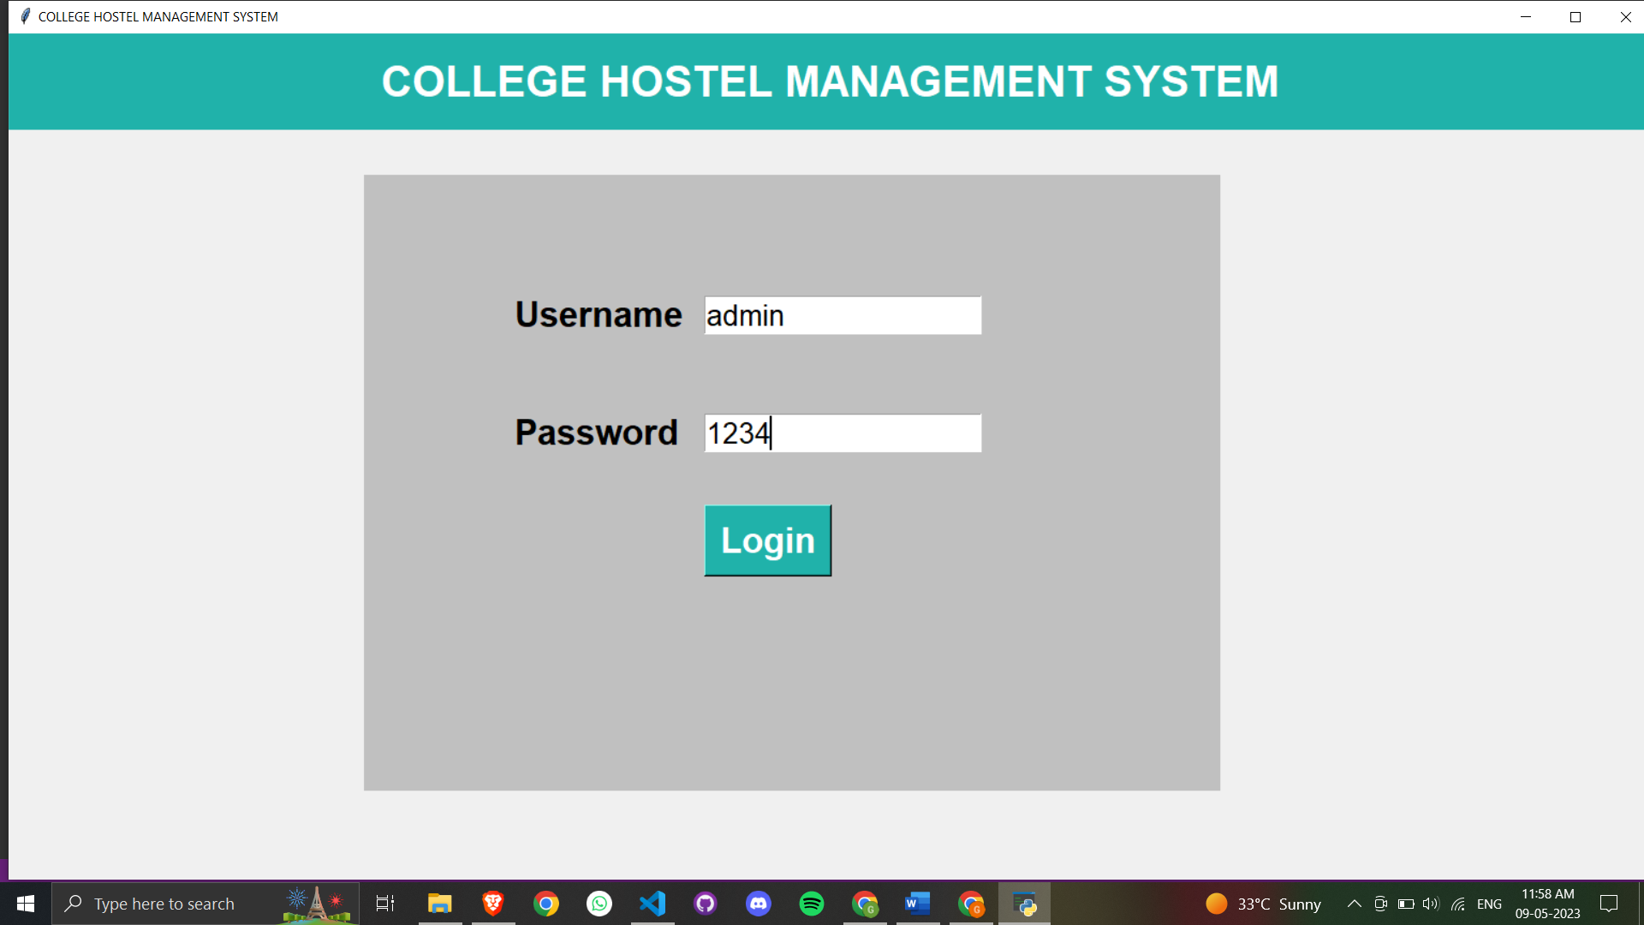

Home Page

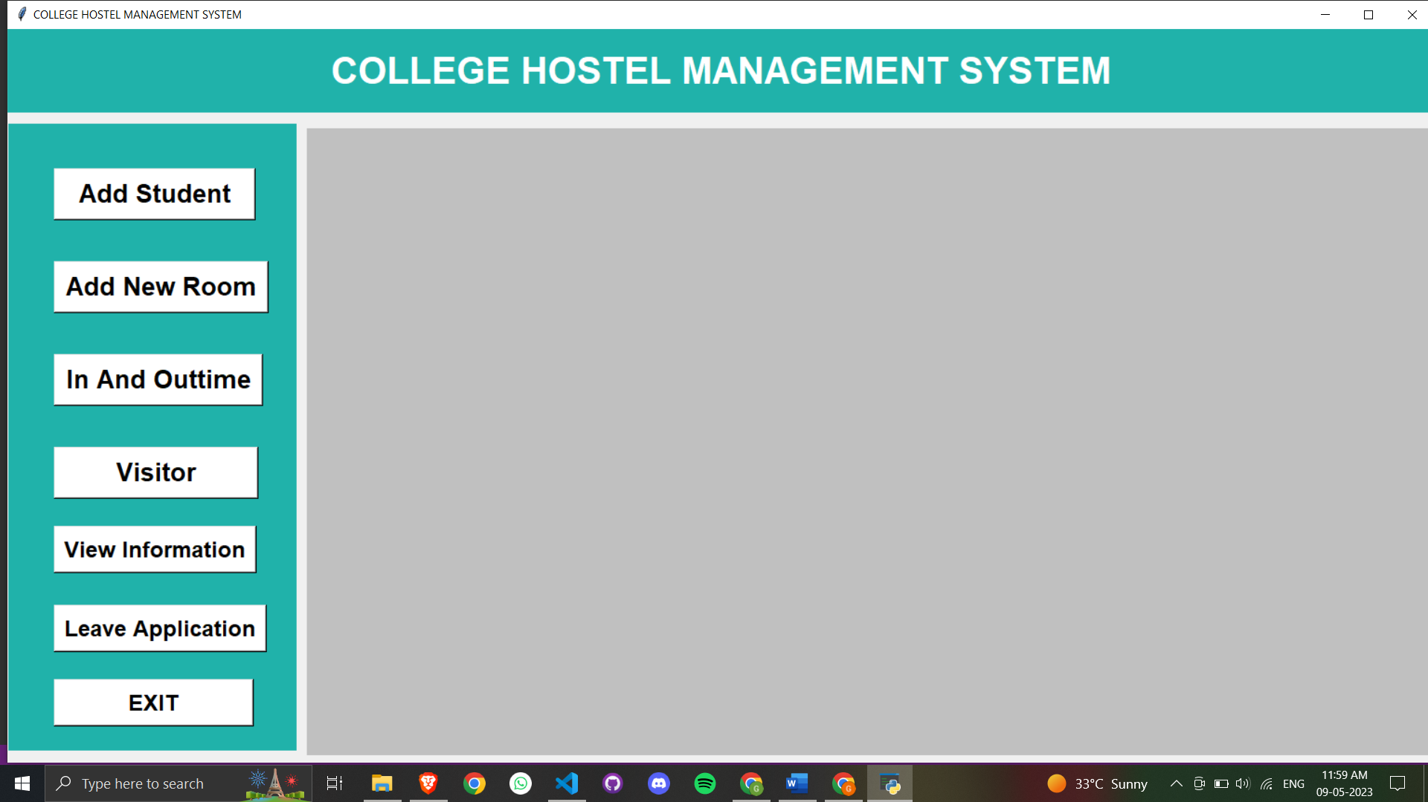

Student Registration Page

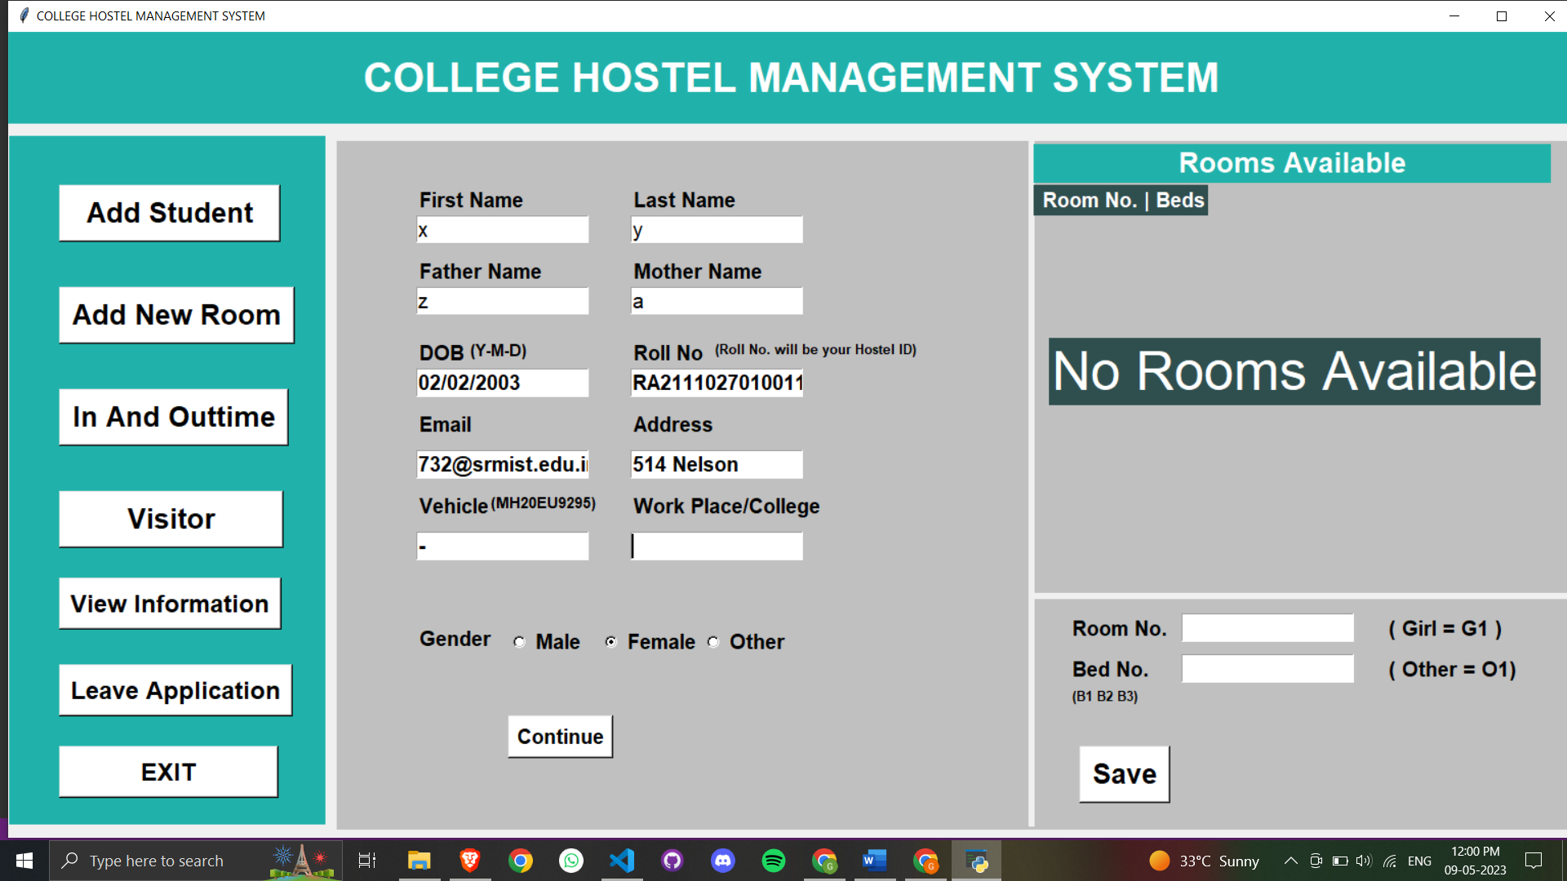

Add New Room Page

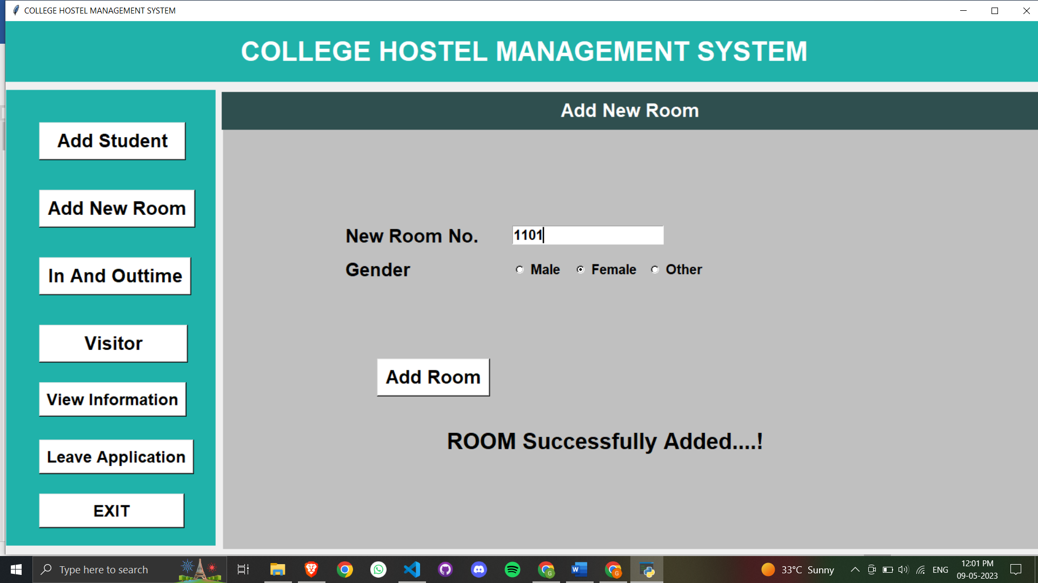

Intime – Out time Page

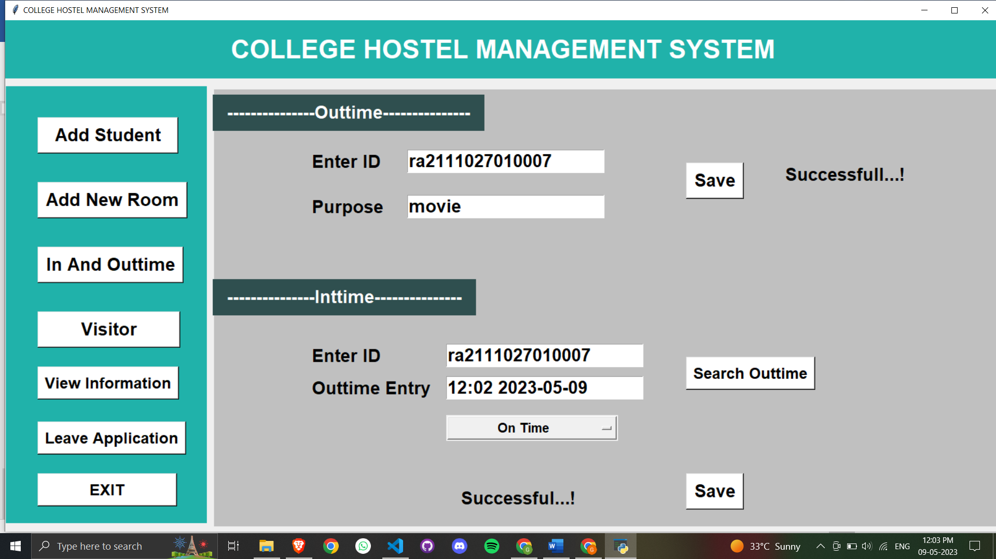

Visitor Page

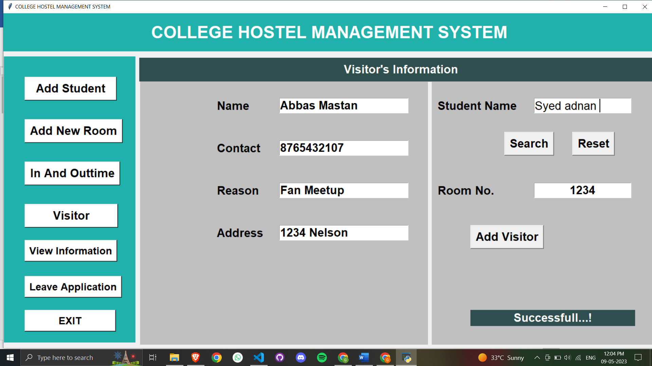

Information of Students and Room

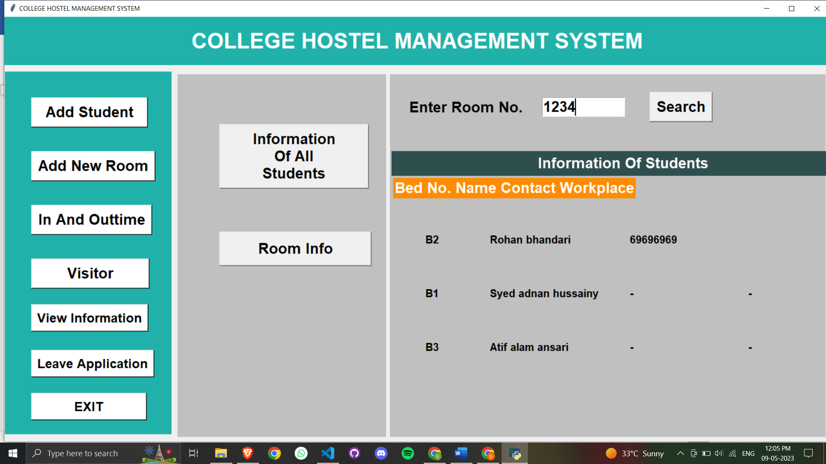

Leave Application Page

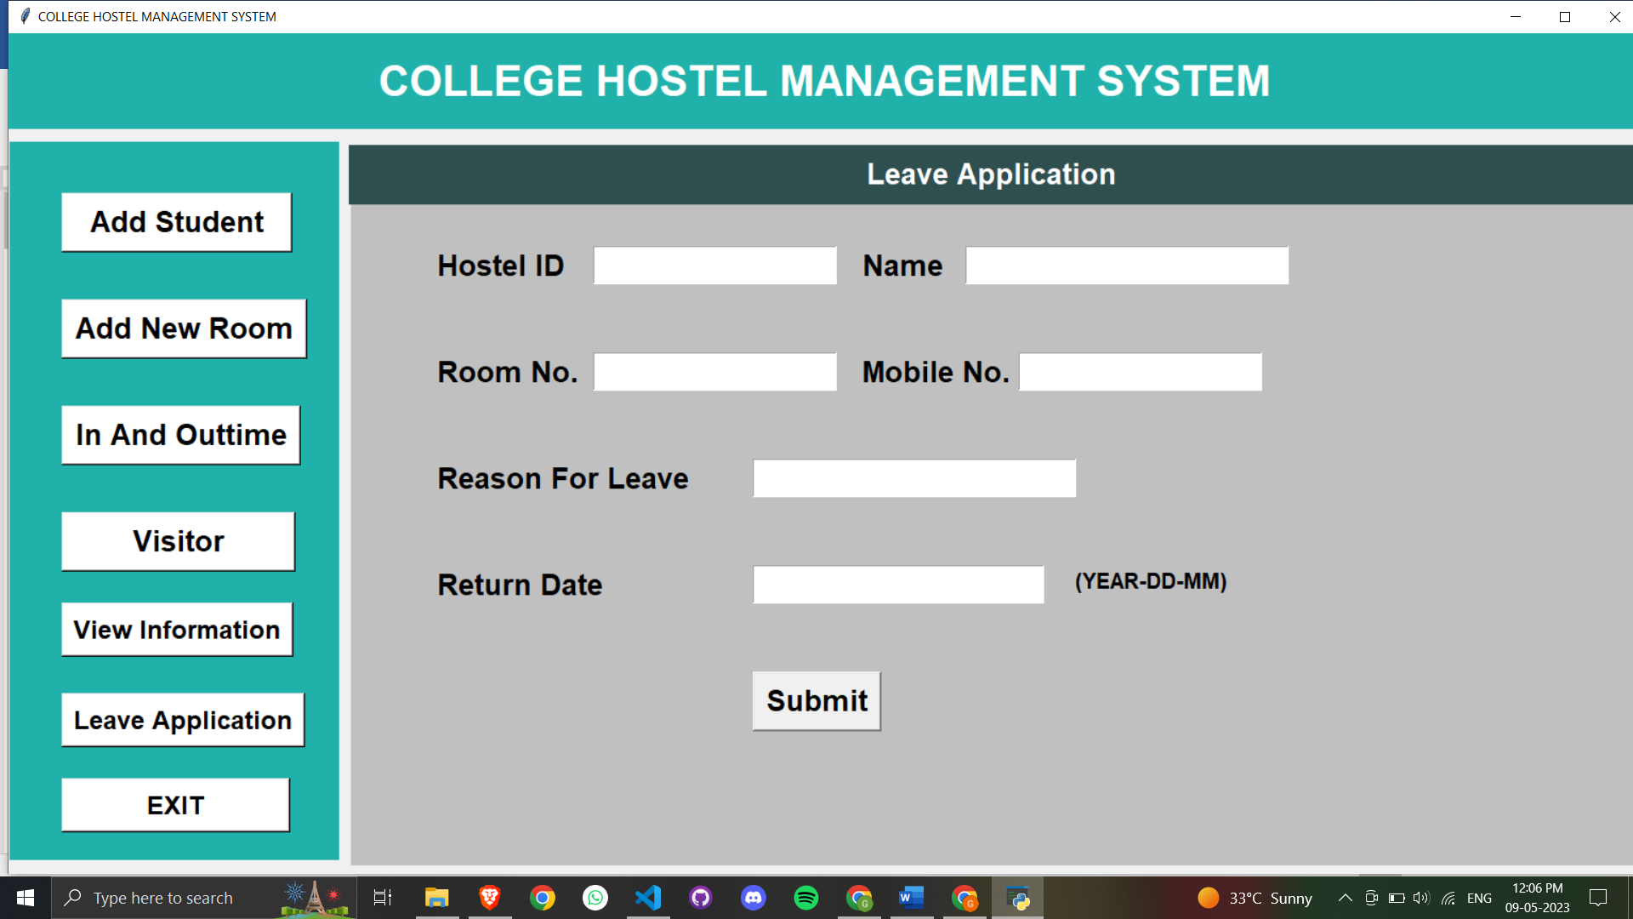

**CONCLUSION**

In conclusion, the University Hostel Management System implemented using Python, Tkinter, and a database provides an efficient and reliable solution for managing hostel accommodation in universities. The system automates the process of room allocation, billing, and management of student records, saving time and reducing errors associated with manual management.

The system is designed using a client-server architecture with a desktop-based client application and a database server. The system is implemented using a Model-View-Controller (MVC) architecture, which separates the system into three components: the model, view, and controller.

The development of the system follows a structured methodology that includes requirements gathering, system analysis and design, implementation, integration and testing, and deployment and maintenance.

The University Hostel Management System is scalable and extensible, making it customizable to meet the specific needs of different universities. The system architecture and design provide a framework for future system enhancements and improvements.

Overall, the University Hostel Management System is a valuable tool for managing hostel accommodation in universities, improving the efficiency and accuracy of the management process while providing a user-friendly interface for hostel administrators and students.

**FUTURE ENHANCEMENTS**

The University Hostel Management System implemented using Python, Tkinter, and a database can be enhanced further to meet the evolving needs of hostel management in universities. Some potential areas for future enhancements include:

1. **Mobile Application:** The system can be extended to include a mobile application that will allow students to check their room allocations, view their bills, and submit requests for maintenance or other services. This will provide greater convenience for students and reduce the workload on hostel administrators.
2. **Gateway Integration:** The system can be integrated with popular payment gateways to enable students to pay their hostel bills online. This will improve the efficiency of the billing process and reduce the workload on hostel administrators.
3. **Integration with Access Control Systems:** The system can be integrated with access control systems to enable hostel administrators to manage access to different parts of the hostel. This will improve security and enable better monitoring of student movements.
4. **Reporting and Analytics:** The system can be enhanced to include reporting and analytics capabilities, allowing hostel administrators to generate reports on occupancy rates, revenue, and other metrics. This will enable better decision-making and planning.
5. **Integration with Smart Devices:** The system can be integrated with smart devices such as sensors and cameras to enable better monitoring of hostel infrastructure and student behavior. This will provide greater insight into hostel operations and enable more efficient management.

**REFERENCES**

* "Tkinter GUI Application Development Projects" by Bhaskar Chaudhary
* "Python for Everybody: Exploring Data in Python 3" by Charles Severance
* "Database Systems: Design, Implementation, and Management" by Carlos Coronel and Steven Morris
* "Software Engineering: A Practitioner's Approach" by Roger Pressman and Bruce Maxim
* "Modern Systems Analysis and Design" by Jeffrey A. Hoffer, Joey F. George, and Joseph S. Valacich
* "Managing Hostel Accommodation in Universities Using an Integrated Information System: A Case Study of Covenant University, Ota, Nigeria" by Ayodeji A. Oluwatobi and Jonathan A. Oke
* "Development of a Hostel Management System using PHP and MySQL" by V. P. Saravanan and R. Saravanakumar
* "Online Hostel Management System" by T. Ch. Pradeep Kumar and K. Naveen Kumar